|  |
| --- |
| Computer Programming |
| CodeHub |
| Mohammad Zain |
|  |
| **zain76035** |
|  |

|  |
| --- |
|  |

Program #01;

A program that will display “Hello World”, “Welcome IUNC” using …. (a) FOR LOOP (b) WHILE LOOP.

[A]

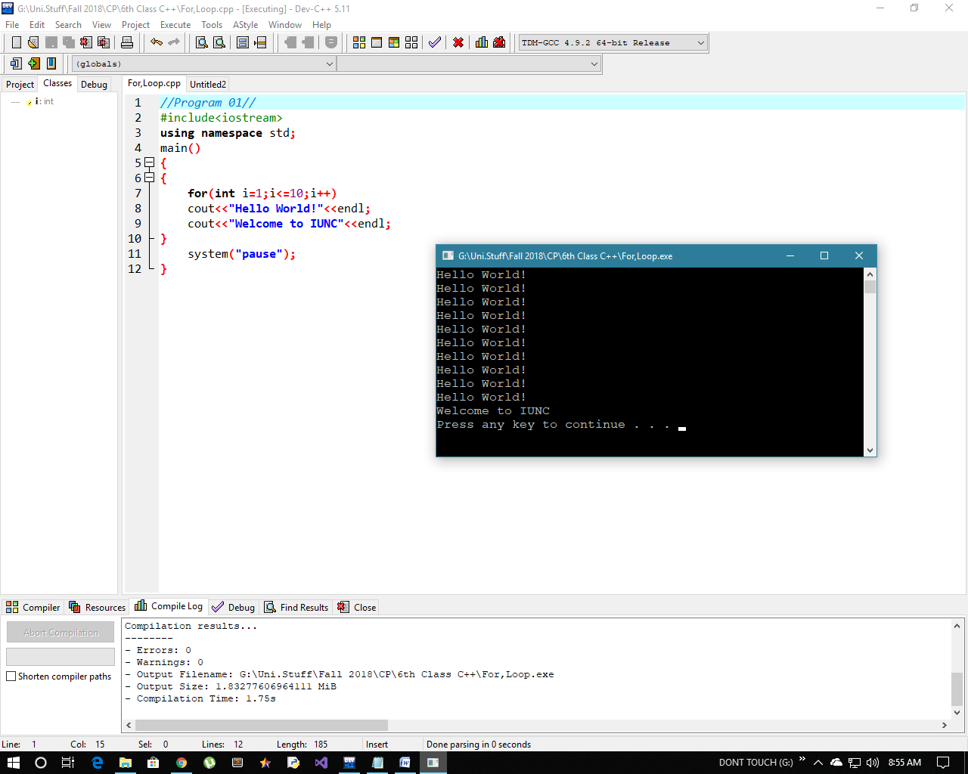

[B]

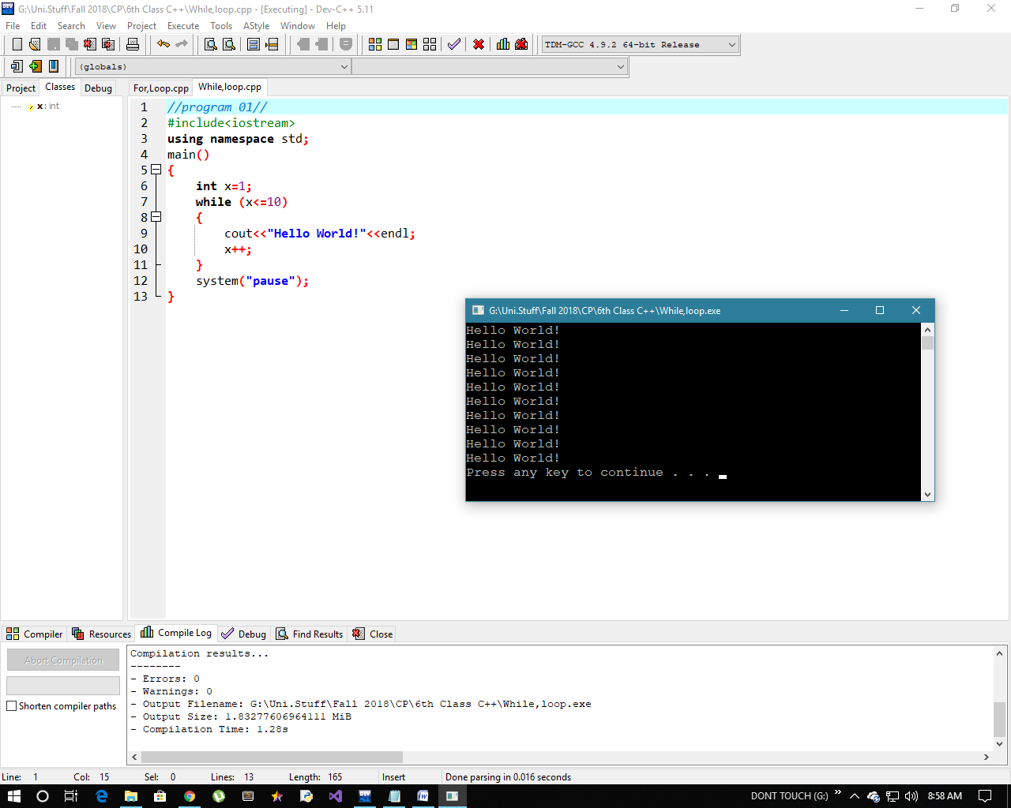

Program # 02;

A program that display your profile. Each Value in new Line 20 times using (a) For loops (b) While Loop.

[A]

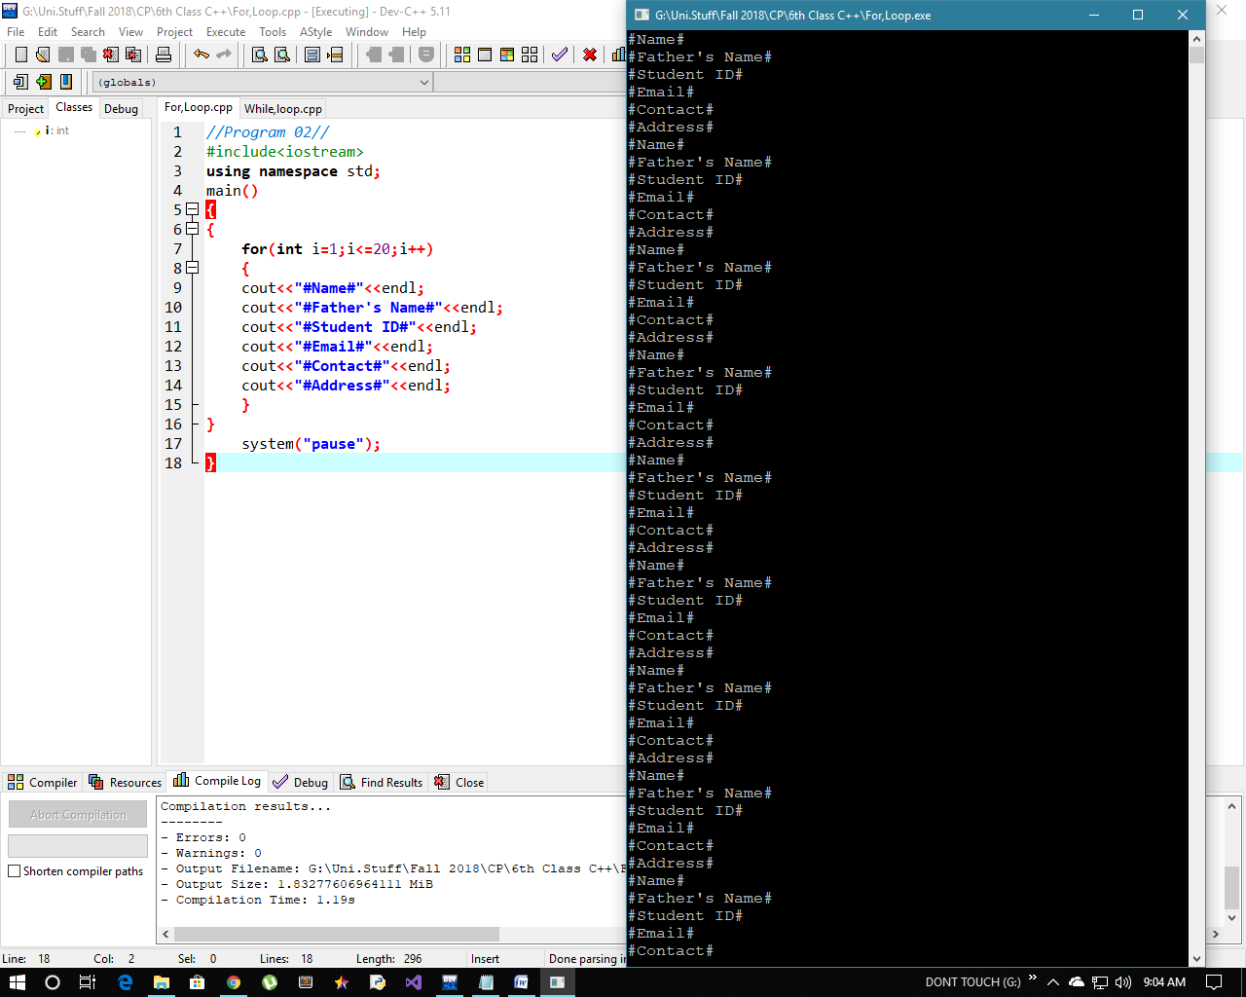

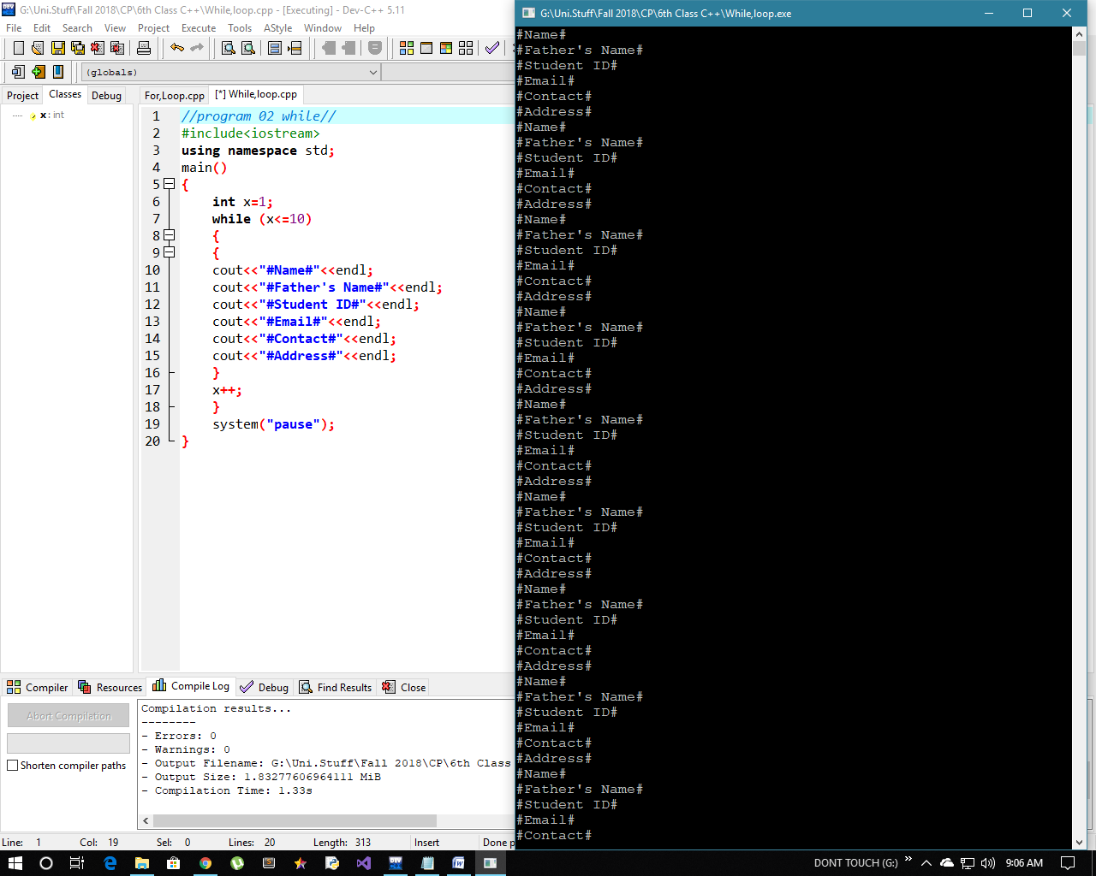[B]

Program # 03;

A program that will asking user to Enter “Three Ints”. Calculate the sum 1st and 3rd and product of 2nd and Double of 2nd value. Display the value of sum 10 times and product 15 times.

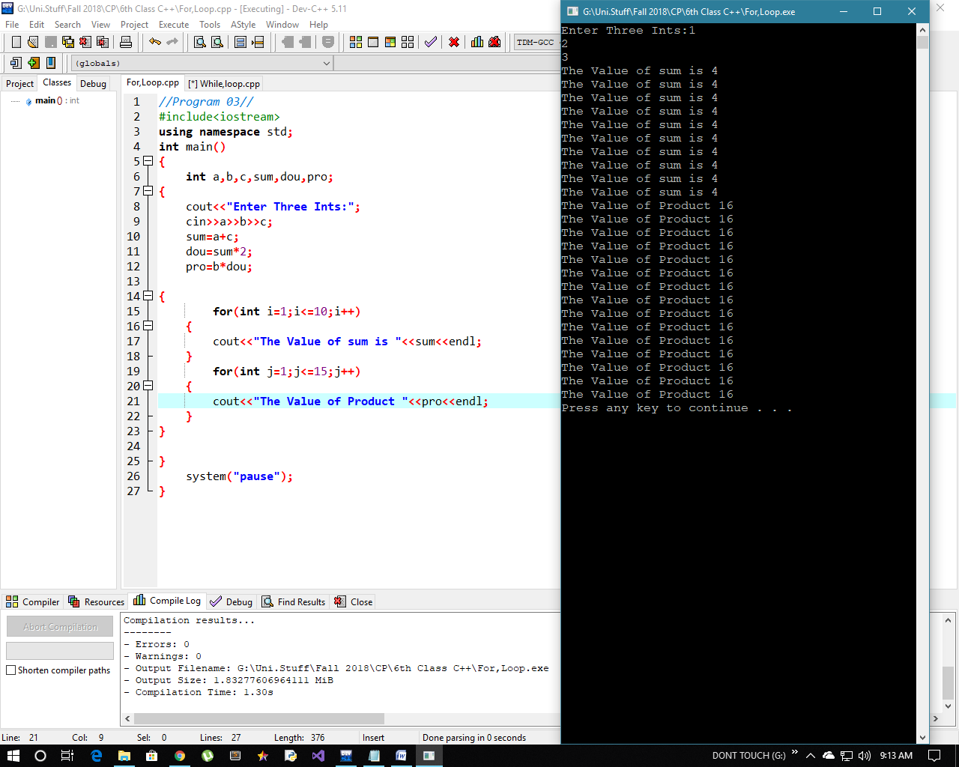

Program # 04;

A program that display first 10 natural using for loop and while.

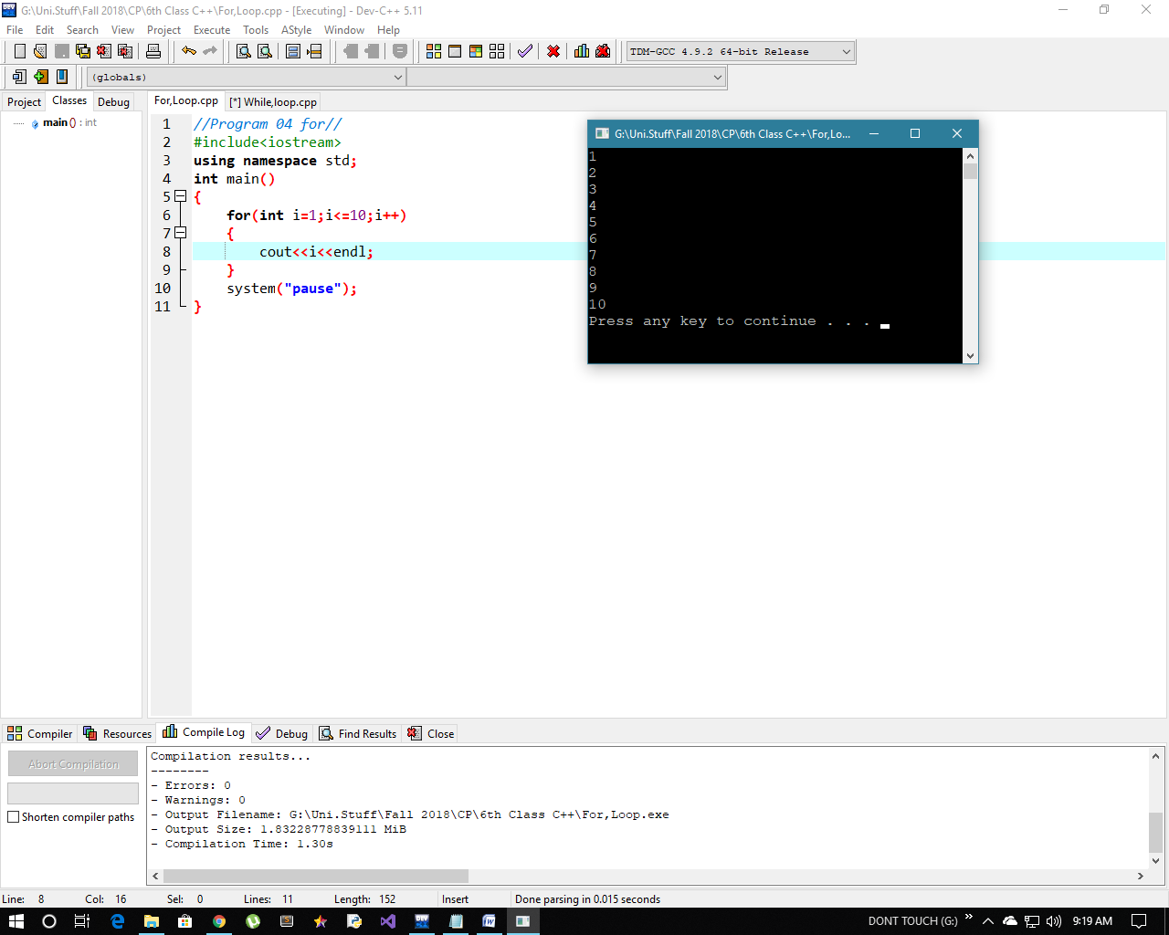[A]

[B]

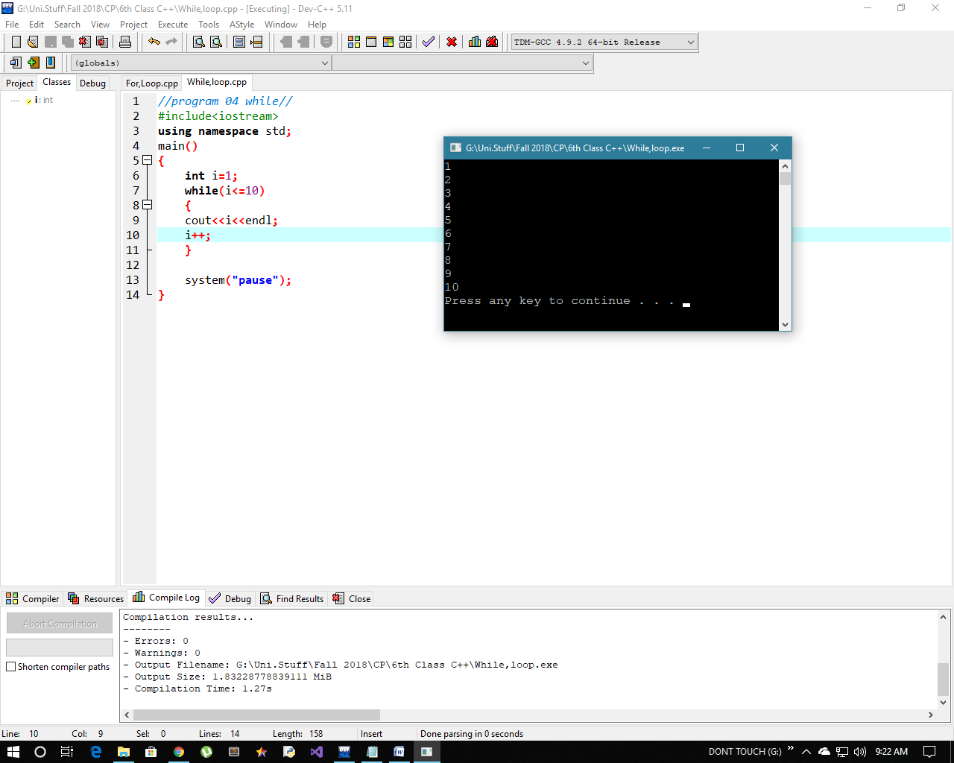

Program # 05 ;

A program that display first 10 natural numbers in descending order using for loop and while.

[A]

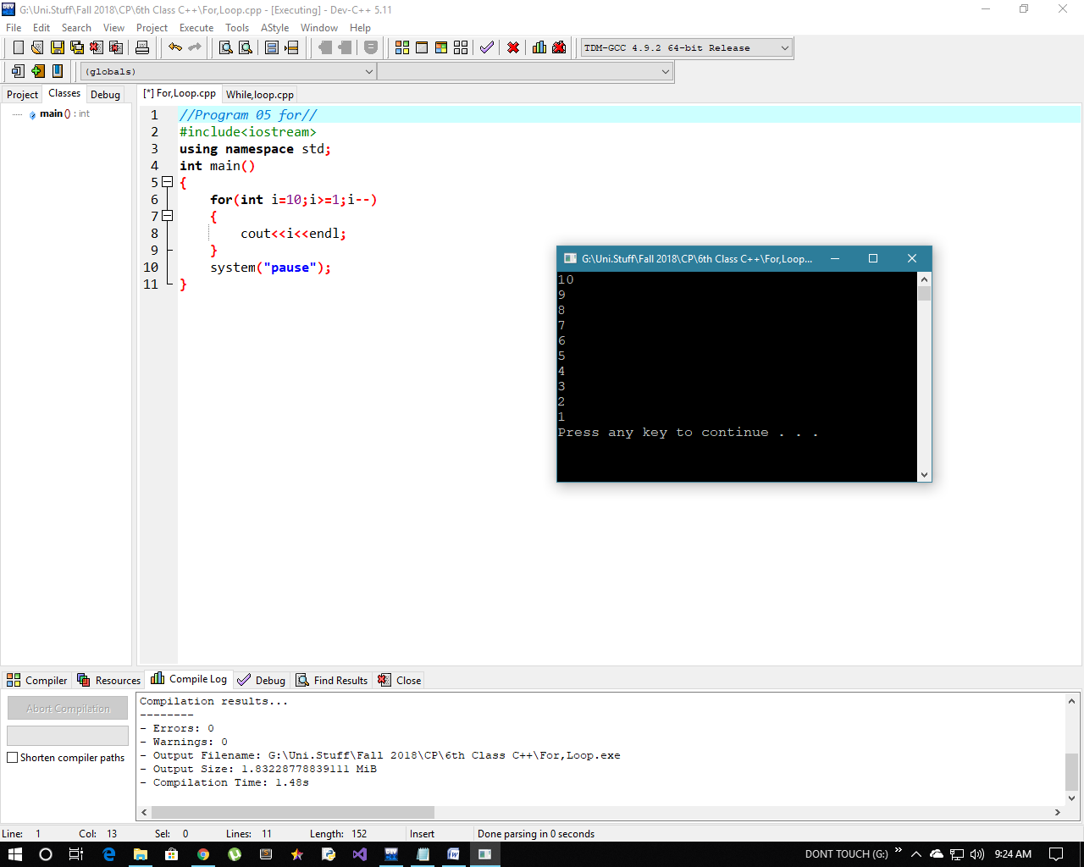

[B]

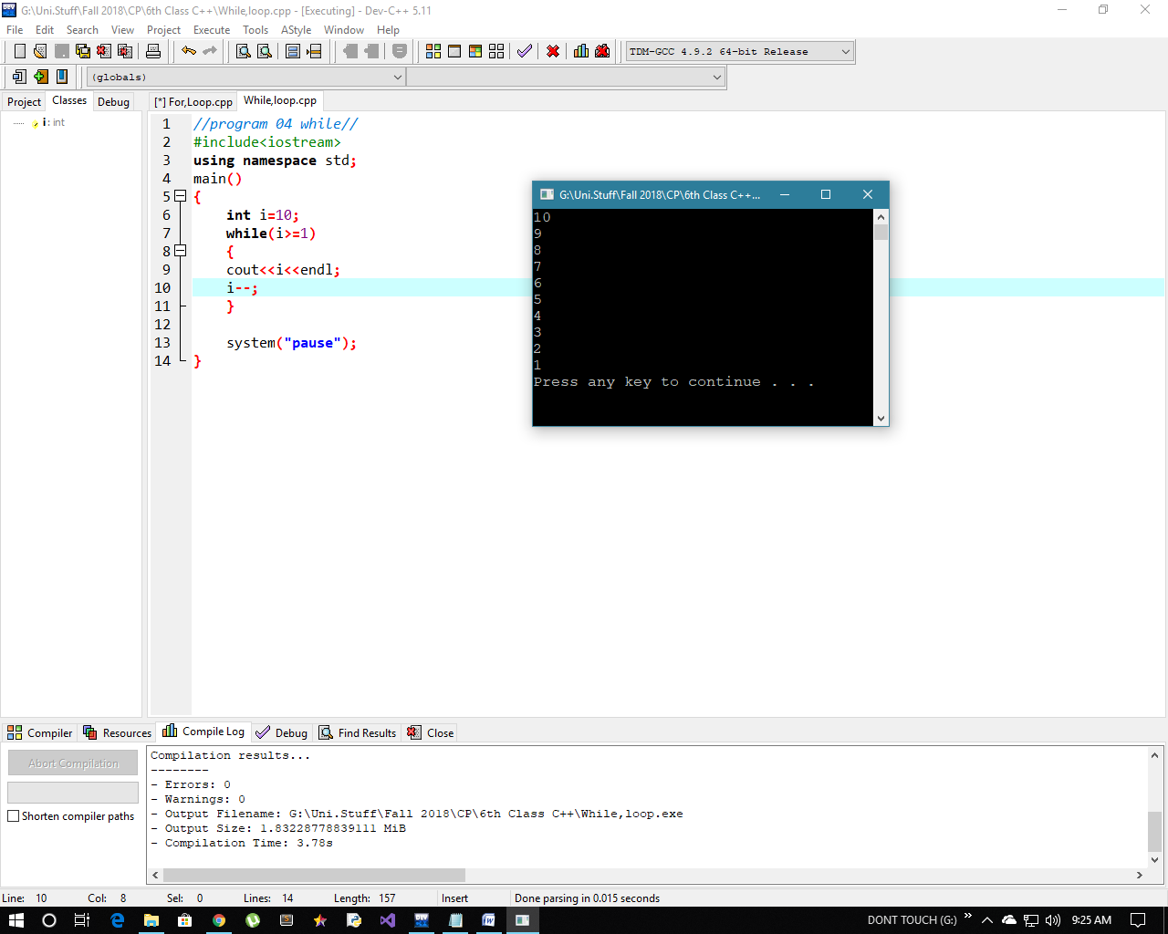

Program # 06;

Program that will display 1st ten even number using for and while loop.

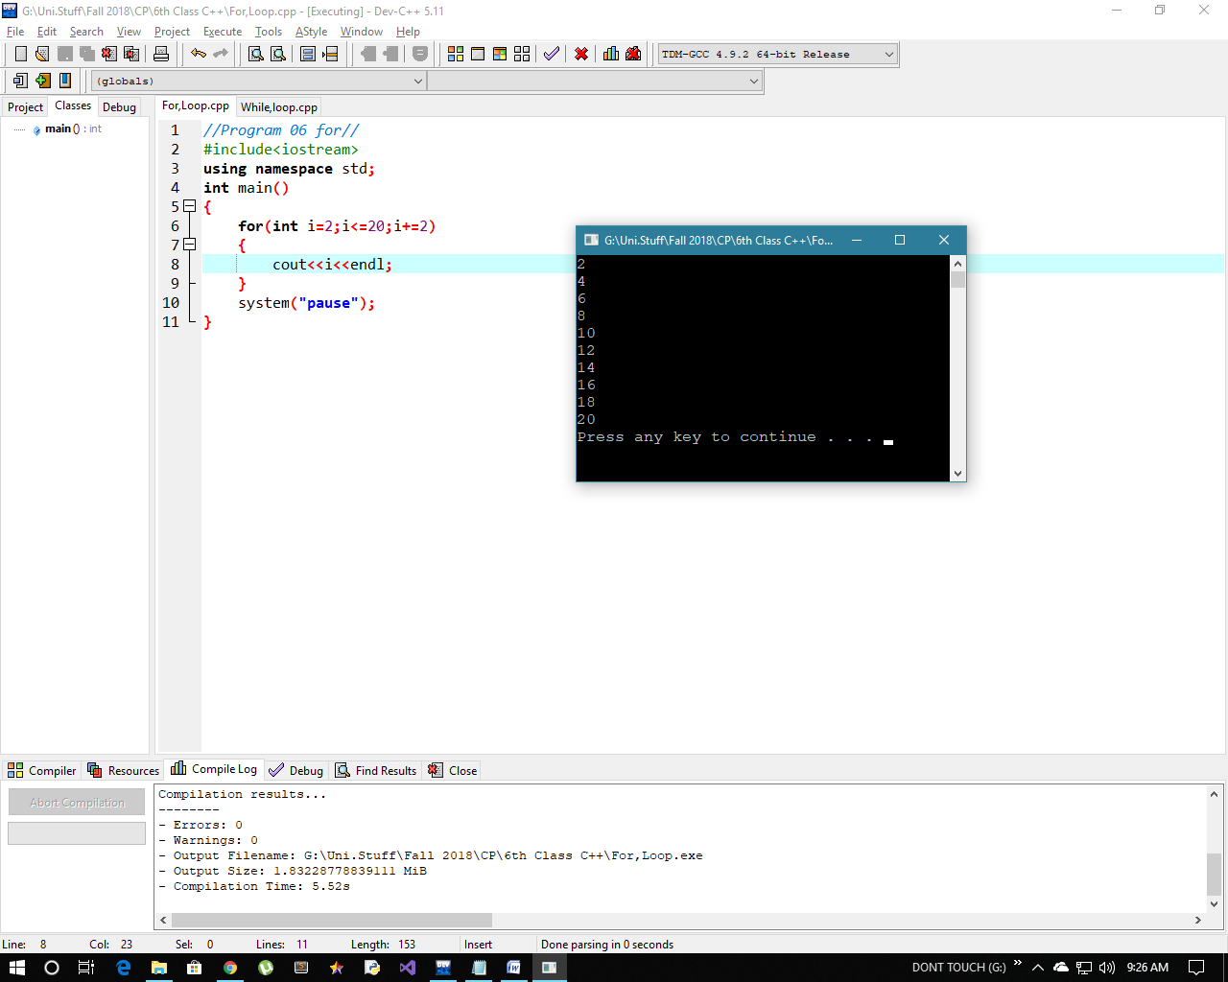[A]

[B]

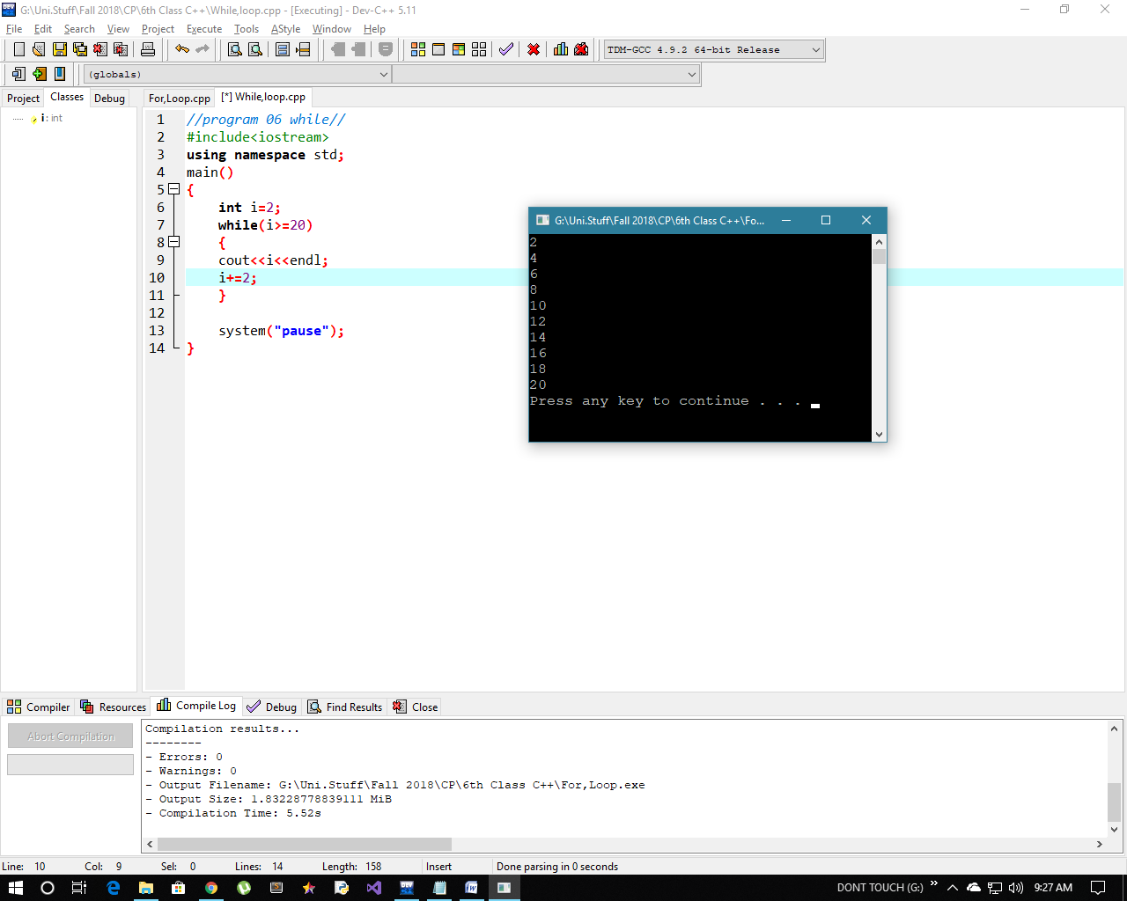

Program # 07;

Program that will be display 1st 15 odd numbers in descending order using for loop and while .

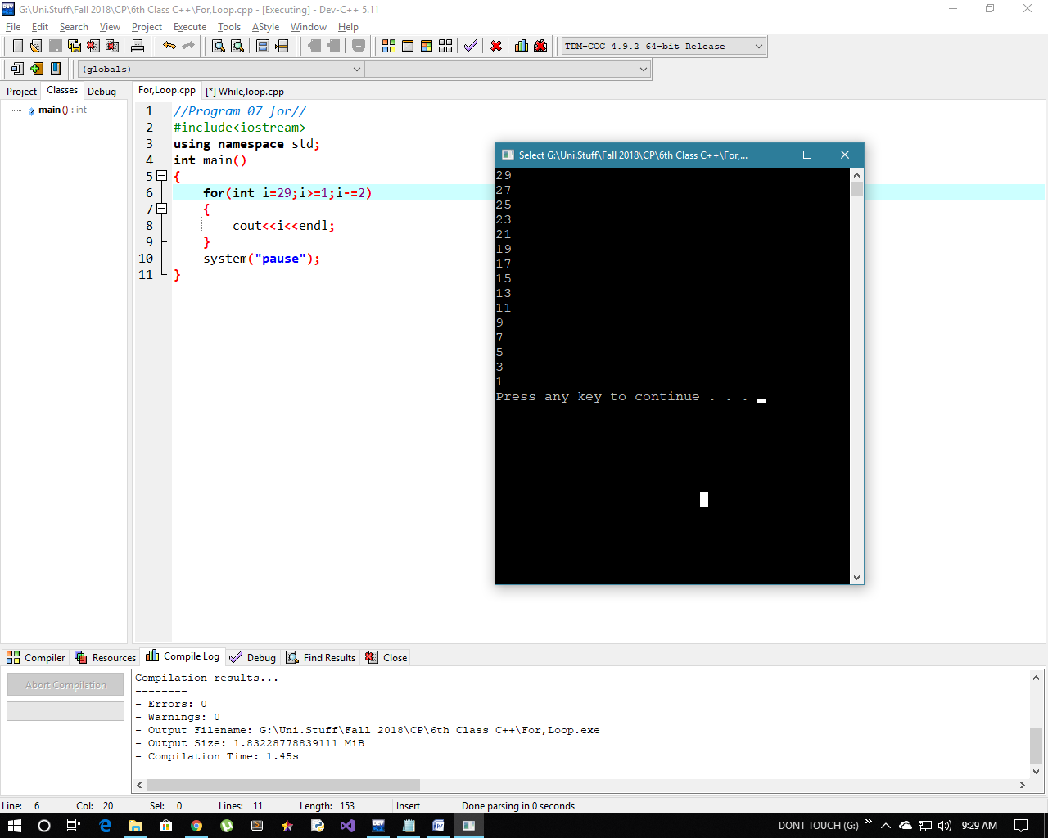[A]

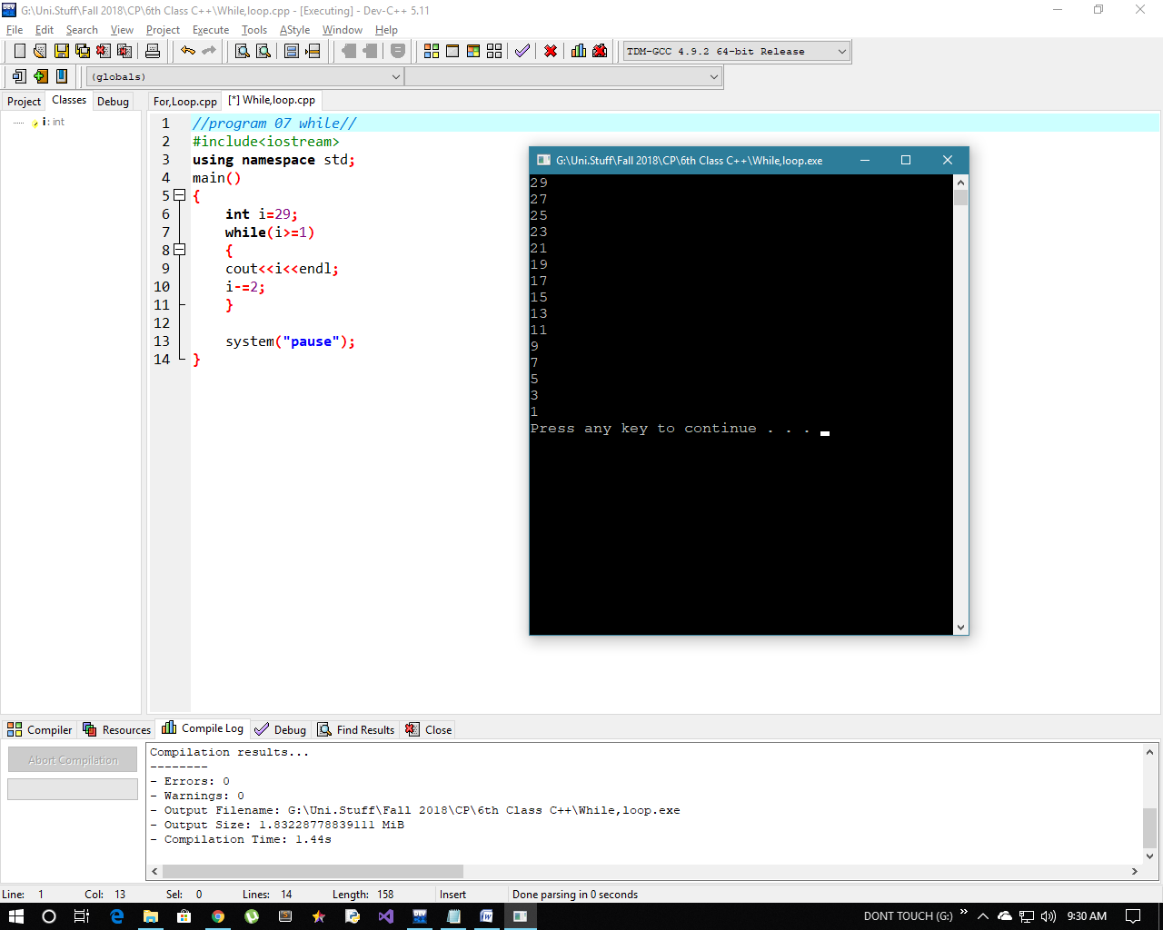[B]

Program # 08;

A program that will take character as input along with an int. Check if character is one of first 4 alphabets. Display the double of int along with next and previous of same value 10 times using for loop.

